3GPP TR 36.763 V0.0.2 (2021-02)
Technical Report

3rd Generation Partnership Project;
Technical Specification Group Radio Access Network;
Study on Narrow-Band Internet of Things (NB-IoT) / enhanced Machine Type Communication (eMTC) support for Non-Terrestrial Networks (NTN) (Release 17)
 | 
The present document has been developed within the 3rd Generation Partnership Project (3GPP TM) and may be further elaborated for the purposes of 3GPP.
The present document has not been subject to any approval process by the 3GPP Organizational Partners and shall not be implemented.
This Specification is provided for future development work within 3GPP only. The Organizational Partners accept no liability for any use of this Specification.
Specifications and Reports for implementation of the 3GPP TM system should be obtained via the 3GPP Organizational Partners' Publications Offices.

3GPP
Postal address

3GPP support office address
650 Route des Lucioles - Sophia Antipolis
Valbonne - FRANCE
Tel.: +33 4 92 94 42 00 Fax: +33 4 93 65 47 16
Internet
http://www.3gpp.org

Copyright Notification
No part may be reproduced except as authorized by written permission.
The copyright and the foregoing restriction extend to reproduction in all media.

© 2019, 3GPP Organizational Partners (ARIB, ATIS, CCSA, ETSI, TSDSI, TTA, TTC).
All rights reserved.

UMTS™ is a Trade Mark of ETSI registered for the benefit of its members
3GPP™ is a Trade Mark of ETSI registered for the benefit of its Members and of the 3GPP Organizational Partners
LTE™ is a Trade Mark of ETSI registered for the benefit of its Members and of the 3GPP Organizational Partners
GSM® and the GSM logo are registered and owned by the GSM Association

Contents
Foreword 4
1 Scope 6
2 References 6
3 Definitions of terms, symbols and abbreviations 6
3.1 Terms 6
3.2 Symbols 8
3.3 Abbreviations 8
4 IoT Non-Terrestrial Networks overview and scenarios 9
4.1 IoT Non-Terrestrial Networks overview 9
4.2 IoT Non-Terrestrial Networks reference scenarios 10
5 IoT-NTN Architecture and Capabilities 10
5.1 IoT-NTN Architecture 10
5.2 IoT-NTN UE Capabilities 11
6 Radio Layer 1 issues and related solutions 11
6.1 IoT NTN Reference Parameters 11
6.2 Link Budget Analysis 13
6.2.1 Link Budget Parameters 13
6.3 Timing Relationships 16
6.4 Time and Frequency Synchronization 17
6.5 HARQ 18
7 Radio Protocol Issues and Solutions 18
7.1 Requirements and key issues 18
7.1.1 Delay 18
7.2 User plane enhancements 19
7.2.1 MAC 19
7.2.2 RLC 21
7.2.3 PDCP 21
7.3 Control plane enhancements 22
7.3.1 Idle mode mobility enhancements 22
7.3.2 Connected mode mobility enhancements 24
8 Recommendations on the way forward 24
8.1 Recommendations from RAN1 24
8.2 Recommendations from RAN2 24
Annex A: Satellite ephemeris 25
B.1 Key Performance Indicators 26
B.2 Performance targets for evaluation purposes 26
Annex C (Informative): Change history 27

Foreword
This Technical Report has been produced by the 3rd Generation Partnership Project (3GPP).
The contents of the present document are subject to continuing work within the TSG and may change following formal TSG approval. Should the TSG modify the contents of the present document, it will be re-released by the TSG with an identifying change of release date and an increase in version number as follows:
Version x.y.z
where:
x the first digit:
1 presented to TSG for information;
2 presented to TSG for approval;
3 or greater indicates TSG approved document under change control.
y the second digit is incremented for all changes of substance, i.e. technical enhancements, corrections, updates, etc.
z the third digit is incremented when editorial only changes have been incorporated in the document.
In the present document, modal verbs have the following meanings:
shall indicates a mandatory requirement to do something
shall not indicates an interdiction (prohibition) to do something
The constructions "shall" and "shall not" are confined to the context of normative provisions, and do not appear in Technical Reports.
The constructions "must" and "must not" are not used as substitutes for "shall" and "shall not". Their use is avoided insofar as possible, and they are not used in a normative context except in a direct citation from an external, referenced, non-3GPP document, or so as to maintain continuity of style when extending or modifying the provisions of such a referenced document.
should indicates a recommendation to do something
should not indicates a recommendation not to do something
may indicates permission to do something
need not indicates permission not to do something
The construction "may not" is ambiguous and is not used in normative elements. The unambiguous constructions "might not" or "shall not" are used instead, depending upon the meaning intended.
can indicates that something is possible
cannot indicates that something is impossible
The constructions "can" and "cannot" are not substitutes for "may" and "need not".
will indicates that something is certain or expected to happen as a result of action taken by an agency the behaviour of which is outside the scope of the present document
will not indicates that something is certain or expected not to happen as a result of action taken by an agency the behaviour of which is outside the scope of the present document
might indicates a likelihood that something will happen as a result of action taken by some agency the behaviour of which is outside the scope of the present document
might not indicates a likelihood that something will not happen as a result of action taken by some agency the behaviour of which is outside the scope of the present document
In addition:
is (or any other verb in the indicative mood) indicates a statement of fact
is not (or any other negative verb in the indicative mood) indicates a statement of fact
The constructions "is" and "is not" do not indicate requirements.

1 Scope
TBA

2 References
The following documents contain provisions, which, through reference in this text, constitute provisions of the present document.
- References are either specific (identified by date of publication, edition number, version number, etc.) or non-specific.
- For a specific reference, subsequent revisions do not apply.
- For a non-specific reference, the latest version applies. In the case of a reference to a 3GPP document (including a GSM document), a non-specific reference implicitly refers to the latest version of that document in the same Release as the present document.
[1] 3GPP TR 21.905: "Vocabulary for 3GPP Specifications"
[2] 3GPP TR 38.811 v15.2.0: "Study on New Radio (NR) to support non-terrestrial networks (Release 15)"
[3] 3GPP TR38.821 v16.0.0: " Solutions for NR to support non-terrestrial networks (NTN) (Release 16)"
[4] 3GPP TR 45.820 v13.1.0: "Cellular system support for ultra-low complexity and low throughput Internet of Things (CIoT) (Release 13)"
[5] 3GPP TS 22.261: "Service requirements for the 5G system; Stage 1 (Release 16)"
[6] R2-1901404: "IoT Device Density Models for Various Environments", Vodafone, RAN2 #105
[7] 3GPP TS 36.331: "E-UTRA Radio Resource Control (RRC) protocol specification (Release 16)"
[8] 3GPP TS 36.322: "E-UTRA Radio Link Control (RLC) protocol specification (Release 16)"
[9] 3GPP TS 36.323: "E-UTRA Packet Data Convergence Protocol (PDCP) specification (Release 16)"
[10] R2-2011275: "[IoT-NTN] Applicability of TR 38.821 (MediaTek)"
[11] 3GPP TS 36.304: "Evolved Universal Terrestrial Radio Access (E-UTRA); UE Procedures in Idle Mode (Release 16)"
[12] 3GPP TS 36.321: "Evolved Universal Terrestrial Radio Access (E-UTRA); Medium Access Control (MAC) protocol specification (Release 16)"

3 Definitions of terms, symbols and abbreviations

3.1 Terms
For the purposes of the present document, the terms and definitions given in TR 21.905 [1] and the following apply. A term defined in the present document takes precedence over the definition of the same term, if any, in TR 21.905 [1].
Availability: % of time during which the RAN is available for the targeted communication. Unavailable communication for shorter period than [Y] ms shall not be counted. The RAN may contain several access network components among which an NTN to achieve multi-connectivity or link aggregation.
Feeder link: Wireless link between NTN Gateway and satellite
Geostationary Earth orbit: Circular orbit at 35,786 km above the Earth's equator and following the direction of the Earth's rotation. An object in such an orbit has an orbital period equal to the Earth's rotational period and thus appears motionless, at a fixed position in the sky, to ground observers.
Low Earth Orbit: Orbit around the Earth with an altitude between 300 km, and 1500 km.
Medium Earth Orbit: region of space around the Earth above low Earth orbit and below geostationary Earth Orbit.
Minimum Elevation angle: minimum angle under which the satellite or UAS platform can be seen by a terminal.
Mobile Services: a radio-communication service between mobile and land stations, or between mobile stations
Mobile Satellite Services: A radio-communication service between mobile earth stations and one or more space stations, or between space stations used by this service; or between mobile earth stations by means of one or more space stations
Non-Geostationary Satellites: Satellites (LEO and MEO) orbiting around the Earth with a period that varies approximately between 1.5 hour and 10 hours. It is necessary to have a constellation of several Non-Geostationary satellites associated with handover mechanisms to ensure a service continuity.
Non-terrestrial networks: Networks, or segments of networks, using an airborne or space-borne vehicle to embark a transmission equipment relay node or base station.
NTN-gateway: an earth station or gateway is located at the surface of Earth, and providing sufficient RF power and RF sensitivity for accessing to the satellite. NTN Gateway is a transport network layer (TNL) node.
On Board processing: digital processing carried out on uplink RF signals aboard a satellite or an aerial.
On board NTN eNB: eNB implemented in the regenerative payload on board a satellite.
On ground NTN eNB: eNB of a transparent satellite payload implemented on ground.
One-way latency: time required to propagate through a telecommunication system from a terminal to the public data network or from the public data network to the terminal. This is especially used for voice and video conference applications.
Regenerative payload: payload that transforms and amplifies an uplink RF signal before transmitting it on the downlink. The transformation of the signal refers to digital processing that may include demodulation, decoding, re-encoding, re-modulation and/or filtering.
Round Trip Delay: time required for a signal to travel from a terminal to the sat-gateway or from the sat-gateway to the terminal and back. This is especially used for web-based applications.
Satellite: a space-borne vehicle embarking a bent pipe payload or a regenerative payload telecommunication transmitter, placed into Low-Earth Orbit (LEO), Medium-Earth Orbit (MEO), or Geostationary Earth Orbit (GEO).
Satellite beam: A beam generated by an antenna on-board a satellite
Service link: Radio link between satellite and UE
Transparent payload: payload that changes the frequency carrier of the uplink RF signal, filters and amplifies it before transmitting it on the downlink
User Connectivity: capability to establish and maintain data / voice / video transfer between networks and Terminals
User Throughput: data rate provided to a terminal

3.2 Symbols
Void

3.3 Abbreviations
For the purposes of the present document, the abbreviations given in TR 21.905 [1] and the following apply. An abbreviation defined in the present document takes precedence over the definition of the same abbreviation, if any, in TR 21.905 [1].

ECEF Earth-Centered, Earth-Fixed
EIRP Equivalent Isotropic Radiated Power
GEO Geostationary Earth Orbiting
eNB 4G Node B
GW Gateway
LEO Low Earth Orbiting
Mbps Mega bit per second
MS Mobile Services
MSS Mobile Satellite Services
NGEO Non-Geostationary Earth Orbiting
NTN Non-Terrestrial Network
RAN Radio Access Network
RTD Round Trip Delay
SNR Signal-to-Noise Ratio
TLE Two-Line Element
Rx Receiver
UE User Equipment

4 IoT Non-Terrestrial Networks overview and scenarios

4.1 IoT Non-Terrestrial Networks overview

A non-terrestrial network refers to a network, or segment of networks using RF resources on board a satellite.
The typical scenario of a non-terrestrial network providing access to user equipment is depicted below:
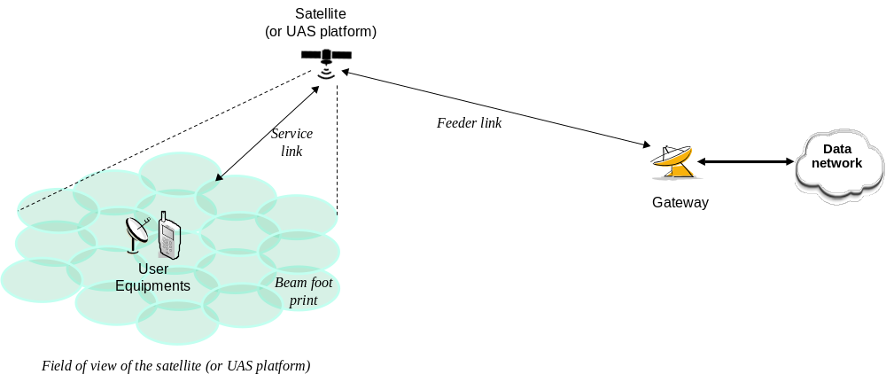

Figure 4.1-1: Non-terrestrial network typical scenario based on transparent payload

Non-Terrestrial Network typically features the following elements:
- One or several sat-gateways that connect the Non-Terrestrial Network to a public data network
- a GEO satellite is fed by one or several sat-gateways which are to enable satellite coverage over the targeted area (e.g. regional or even continental coverage). It is assumed that UE in a cell are served by only one sat-gateway
- A Non-GEO satellite served successively by one or several sat-gateways at a time. The system ensures service and feeder link continuity between the successive serving sat-gateways with sufficient time duration to proceed with mobility anchoring and hand-over
- A Feeder link or radio link between a sat-gateway and the satellite
- A service link or radio link between the user equipment and the satellite.
- A satellite which implements a transparent payload. The satellite typically generate several beams over a given service area bounded by its field of view. The beam could be either earth fixed beam or earth moving beam for LEO. The footprints of the beams are typically of elliptic shape. The field of view of a satellite depends on the on board antenna design and minimum elevation angle.
- A transparent payload: Radio Frequency filtering, Frequency conversion and amplification. Hence, the waveform signal repeated by the payload is un-changed;
- User Equipment are served by the satellite within the targeted service area.

There may be different types of satellites listed here under:
Table 4.1-1: Types of NTN platforms
Platforms | Altitude range | Orbit | Typical beam footprint size
Low-Earth Orbit (LEO) satellite | 300 – 1500 km | Circular around the earth | 100 – 1000 km
Geostationary Earth Orbit (GEO) satellite | 35 786 km | notional station keeping position fixed in terms of elevation/azimuth with respect to a given earth point | 200 – 3500 km

Typically
- GEO satellites are used to provide continental, regional or local service.
- A constellation of LEO satellites is used to provide services in both Northern and Southern hemispheres. In some case, the constellation can even provide global coverage including polar regions. For the later, this requires appropriate orbit inclination, sufficient beams generated and inter-satellite links.

4.2 IoT Non-Terrestrial Networks reference scenarios
The study captured in this Technical Report considers non-terrestrial networks for IoT service providing access to NB-IoT/eMTC user equipment in reference scenarios including:
- GEO and LEO orbiting scenarios
- No inter-satellite link
- Transparent payload
- Fixed or steerable beams resulting respectively in moving or fixed beam footprint on the ground
- Sub 6 GHz bands of interest.
IoT NTN scenarios A, B, and C are included in the study as shown in Table 4.2-1 below:

Table 4.2-1: IoT NTN reference scenarios
NTN Configurations | Transparent satellite
GEO based non-terrestrial access network | Scenario A
LEO based non-terrestrial access network generating steerable beams (altitude 1200 km and 600km) | Scenario B
LEO based non-terrestrial access network generating fixed beams whose footprints move with the satellite (altitude 1200 km and 600km) | Scenario C

5 IoT-NTN Architecture and Capabilities

5.1 IoT-NTN Architecture
IoT NTN connectivity via EPC is supported.
Editor’s Note: Support for IoT NTN connectivity via 5GCN is under discussion.

5.2 IoT-NTN UE Capabilities
GNSS capability in the UE is taken as a working assumption in this study for both NB-IoT and eMTC devices.
Editor’s Note: UE can estimate and pre-compensate timing and frequency offset with sufficient accuracy for UL transmission - FFS pending RAN1 decision.
Simultaneous GNSS and NTN NB-IoT/eMTC operation is not assumed.

6 Radio Layer 1 issues and related solutions

6.1 IoT NTN Reference Parameters
The IoT NTN reference scenario parameters are listed in Table 6.1-1 below:
Table 6.1-1: IoT NTN reference scenario parameters
Scenarios | GEO based non-terrestrial access network - scenario A | LEO based non-terrestrial access network -Scenario B & C
Orbit type | station keeping a nominally fixed position in terms of elevation/azimuth with respect to a given earth point | circular orbiting at low altitude around the earth
Altitude | 35,786 km | 600 km  1,200 km
Frequency Range (service link) | < 6 GHz (e.g. 2 GHz in S band)
Device channel Bandwidth (service link) (NOTE 7) | - NB-IoT 180 kHz (DL), Up to 180 kHz with all permissible smaller resource allocations 12*15 kHz, 6*15 kHz, 3*15 kHz, 1*15 kHz, 1*3.75 kHz (UL)  - eMTC: 1080 kHz (DL), Up to 1080 kHz with all permissible smaller resource allocations, including 2*180 kHz, 180 kHz, 2*15 kHz or 3*15 kHz or 6*15 kHz (UL)
Payload | Transparent type | Transparent Type
Earth-fixed beams | Yes | Scenario B: Yes (steerable beams), see NOTE 1  Scenario C: No (the beams move with the satellite)
Max beam footprint size (edge to edge) regardless of the elevation angle | 3500 km (NOTE 3) | 1000 km (NOTE 2)
Min Elevation angle for both sat-gateway and C-IoT device | 10° for service link and 10° for feeder link | 10° for service link and 10° for feeder link
Max distance between satellite and C-IoT device at min elevation angle | 40,581 km | 1,932 km (600 km altitude)  3,131 km (1,200 km altitude)
Max Round Trip Delay (propagation delay only) | 541.46ms (service and feeder links) | 25.77 ms (600km) (service and feeder links)  41.77 ms (1200km) (service and feeder links)
Max differential delay within a cell | 10.3 ms | 3.12 ms and 3.18 ms for respectively 600km and 1200km
Max Doppler shift (earth fixed user equipment) (NOTE 6) | 0.93 ppm | 24 ppm (600km)  21ppm(1200km)
Max Doppler shift variation (earth fixed user equipment) (NOTE 6) | 0.000 045 ppm/s | 0.27 ppm/s (600km)  0.13 ppm/s (1200km)
C-IoT device motion on the earth | Min 0 km/s (stationary device), max 120 km/h | Min 0 km/s (stationary device), max 120 km/h
C-IoT device antenna types | Omnidirectional antenna with 0 dBi TX antenna gain and 0 dBi RX antenna gain (NOTE 4)
C-IoT device max Tx power | UE power class 3 with up to 200 mW (23dBm), UE power class 5 with up to 100 mW (20 dBm)
C-IoT device Noise Figure | Omnidirectional antenna: 7 dB or 9 dB (NOTE 5)
Service link | 3GPP defined Narrow Band IoT and eMTC
NOTE 1: Each satellite has the capability to steer beams towards fixed points on earth using beamforming techniques. This is applicable for a period of time corresponding to the visibility time of the satellite.
NOTE 2: This beam size refers to the Nadir pointing of the satellite.
NOTE 3: The Maximum beam footprint size for GEO is based on current state of the art GEO High Throughput systems, assuming either spot beams at the edge of coverage (low elevation) or a single wide-beam.
NOTE 4: The use of a Circular polarized antenna is optional.
NOTE 5: Same Noise Figure of 7 dB as in Release 16 TR 38.821 or 9 dB as in Release 12 TR 36.888 for device can be assumed for link budget. The noise figure is device vendor implementation specific.
NOTE 6: Max Doppler shift and Max Doppler shift variation in the absence of any device pre-compensation of satellite Doppler shift on the service link.
NOTE 7: System bandwidth is FFS

6.2 Link Budget Analysis

6.2.1 Link Budget Parameters

The following assumptions are agreed for a common set of link budget parameters:
- UE power class (PC5=20 dBm)
- UE Noise Figure (NF=9 dB)
- Channel Bandwidth for NB-IoT and eMTC as was included in IoT NTN reference scenario parameters agreed in RAN1#103e:
- NB-IoT 180 kHz (DL), Up to 180 kHz with all permissible smaller resource allocations 12*15 kHz, 6*15 kHz, 3*15 kHz, 1*15 kHz, 1*3.75 kHz (UL)
- eMTC: 1080 kHz (DL), Up to 1080 kHz with all permissible smaller resource allocations, including 2*180 kHz, 180 kHz, 2*15 kHz or 3*15 kHz or 6*15 kHz (UL)
- Other losses:
Table 6.2-1: Other losses
Other Losses | GEO (35786 km) | LEO (1200 km) | LEO (600 km)
Scintillation losses | 2.2 | 2.2 | 2.2
Atmospheric losses | 0.2 | 0.1 | 0.1
Polarization loss | 3 | 3 | 3
Shadow margin | 3 | 3 | 3

NOTE 1: With PC3 (23 dBm) there is a 3dB gain compared to the PC5 (20 dBm) assumption on UL.
NOTE 2: With NF=7 dB, there is a 2 dB improvement compare to NF=9 dB on DL.
NOTE 3: Link budgets with other link budget parameters are not excluded from being captured in the TR.
NOTE 4: These parameters are only for the purpose of link budget calculations.
NOTE 5: Atmospheric losses are a function of elevation angle.
Link budget analysis assumes 3 dB polarization loss for DL and 3 dB polarization loss on UL for satellite parameters Set 1, Set 2, Set 3, and Set 4
For the satellite parameter sets Set-3 and Set-4, the 3 dB beam width (HPBW), central beam center elevation and central beam edge elevation in the satellite parameter set(s) to be used in link budget calculations are given in Tables 6.2-2 and 6.2-3. These parameters correspond to the satellite parameter Set 3 and Set 4 given in Tables 6.2-6 and 6.2-7 respectively.
Table 6.2-2: Set-3 parameters for link budget analysis
SET 3 | GEO 35786 km | LEO-600 km | LEO-1200 km
3 dB Beam width (HPBW) | 0.735 degree | 22.0631 degree | 22.0631 degree
Central beam center elevation | 20.88 degree | 43.78 degree | 46.05 degree
Central beam edge elevation | 12.5 degree | 30 degree | 30 degree
Central beam edge satellite-UE distance | 40316 km | 1074 km | 1998 km

Table 6.2-3: Set-4 parameters for link budget analysis
SET 4 | LEO-600 km
3 dB Beam width (HPBW) | 104.7 degree
Central beam center elevation | 90 degree
Central beam edge elevation | 30 degree
Central beam edge satellite-UE distance | 1076 km

NOTE 1: The 3 dB beam width (HPBW) is already included in satellite parameter set 1 and Set 2 in TR 38.821 Table 6.1.1.1-1 and Table 6.1.1.1-2 respectively. The central beam center elevation for Set-1 and Set-2 is defined as the target elevation angle that is included in in TR 38.821 Table 6.1.3.2-1. The central beam edge satellite-UE distance can be derived from the central beam edge elevation and does not need to be included.
NOTE 2: Central beam center elevation is the beam center elevation of the central beam in the beam layout.
NOTE 3: Central beam edge elevation is the minimum beam edge elevation of the central beam in the beam layout.
NOTE 4: In SLS evaluation with a multiple beam layout, the central beam is the serving beam for UEs. The outer beams have beam center elevation that is different from the central beam center elevation. For the interference modelling, the interference due to the outer beams is determined by using their respective beam center elevations.
NOTE 5: For the multiple-beam satellite cell, the longest beam edge distance will correspond to the minimum beam edge elevation of the most outer beam as illustrated in figure below.

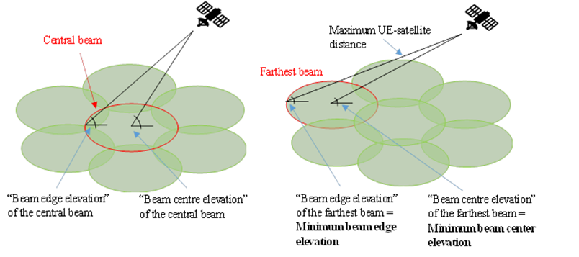
Figure 6.2-1 Illustration of beam layout and elevation angles for IoT NTN

The following satellite set parameters Set-1, Set-2, Set-3, and Set-4 given in Tables 6.2-4, 6.2-5, 6.2-6 and 6.2-7, respectively, can be used for the for the system level simulator calibration.
Table 6.2-4: Set 1 satellite parameters (based on TR 38.821, Table 6.1.1.1-1)

Table 6.2-5: Set 2 satellite parameters (based on TR 38.821, Table 6.1.1.1-2)

Table 6.2-6: Set-3 satellite parameters for system level simulator calibration
(based on R1-2101146 - Eutelsat)
Satellite orbit |  | GEO | LEO-1200 | LEO-600
Satellite altitude |  | 35786 km | 1200 km | 600 km
Central beam edge elevation |  | 12.5 degree | 30 degree | 30 degree
Central beam center elevation |  | 20.9 degree | 46.05 degree | 43.8 degree
Payload characteristics for DL transmissions
Equivalent satellite antenna aperture (NOTE 1) | S-band  (i.e. 2 GHz) | 12 m | 0.4m | 0.4 m
Satellite EIRP density | S-band  (i.e. 2 GHz) | 59.8 dBW/MHz | 33.7 dBW/MHz | 28.3 dBW/MHz
Satellite Tx max Gain | S-band  (i.e. 2 GHz) | 45.7 dBi | 16.2 dBi | 16.2 dBi
3dB beam width (HPBW) | S-band  (i.e. 2 GHz) | 0.7353 degree | 22.1 degree | 22.1 degree
Satellite beam diameter (NOTE 2) | S-band  (i.e. 2 GHz) | 459km | 470 km | 234 km
Payload characteristics for UL transmissions
Equivalent satellite antenna aperture (NOTE 1) | S-band  (i.e. 2 GHz) | 12 m | 0.4 m | 0.4 m
G/T | S-band  (i.e. 2 GHz) | 16.7dB K⁻¹ | -12.8 dB K⁻¹ | -12.8 dB K⁻¹
Satellite Rx max Gain | S-band  (i.e. 2 GHz) | 45.7 dBi | 16.2 dBi | 16.2 dBi
NOTE 1: This value is equivalent to the antenna diameter in Sec. 6.4.1 of TR 38.811
NOTE 2: Satellite beam diameter is at Nadir point
NOTE 3: Central beam center elevation is referred to as central beam elevation in TR 38.821
NOTE 4: Central beam edge elevation is the minimum beam edge elevation of the central beam in the beam layout.

Table 6.2-7: Set-4 satellite parameters for system level simulator calibration
(based on R1-2101019 - Thales, Sateliot, Gatehouse)
Satellite orbit |  | LEO-600
Satellite altitude |  | 600 km
Central beam edge elevation |  | 30 degree
Central beam center elevation |  | 90 degree
Payload characteristics for DL transmissions
Equivalent satellite antenna aperture (NOTE 1) | S-band  (i.e. 2 GHz) | 0.097 m
Satellite EIRP density | S-band  (i.e. 2 GHz) | 21.45 dBW/MHz
Satellite Tx max Gain | S-band  (i.e. 2 GHz) | 11 dBi
3dB beam width (HPBW) | S-band  (i.e. 2 GHz) | 104.7 degree
Satellite beam diameter (Note 2) | S-band  (i.e. 2 GHz) | 1700 km
Payload characteristics for UL transmissions
Equivalent satellite antenna aperture (NOTE 1) | S-band  (i.e. 2 GHz) | 0.097 m
G/T | S-band  (i.e. 2 GHz) | - 18.6 dB·K⁻¹
Satellite Rx max Gain | S-band  (i.e. 2 GHz) | 11 dBi
NOTE 1: This value is equivalent to the antenna diameter in Sec. 6.4.1 of TR 38.811
NOTE 2: Satellite beam diameter is at Nadir point
NOTE 3: Central beam center elevation is referred to as central beam elevation in TR 38.821
NOTE 4: Central beam edge elevation is the minimum beam edge elevation of the central beam in the beam layout.

6.3 Timing Relationships
The following aspects related to timing relationships enhancements will be studied to check whether enhancement is necessary and beneficial:
- For NB-IoT:
- NPDCCH to NPUSCH format 1
- RAR grant to NPUSCH format 1
- NPDSCH to HARQ-ACK on NPUSCH format 2
- NPDCCH order to NPRACH
- Timing advance command activation
- FFS: Other NB-IoT timing relationships

- For eMTC:
- MPDCCH to PUSCH
- RAR grant to PUSCH
- PDCCH order to PRACH
- MPDCCH to scheduled uplink SPS
- PUSCH to HARQ-ACK on PUCCH
- CSI reference resource timing
- MPDCCH to aperiodic SRS
- Timing advance command activation
- FFS: Other eMTC timing relationships

- Impact of large RTD (which impacts TA) on HD-FDD UL-DL timing relationships.

The study will identify IoT-NTN configurations needing activation/de-activation via MAC CE and their timing relationships.

6.4 Time and Frequency Synchronization
The following aspects related to enhancements to time and frequency synchronization will be studied:
- GNSS measurement window for initial access
- Potential impact of GNSS Position fix on UE power consumption considering at least the following parameters:
- GNSS power consumption value
- GNSS position Time To First Fix
- Potential impact of NTN SIB carrying the satellite ephemeris on:
- UE power consumption in NB-IoT and eMTC
- Accuracy of satellite location tracking
- RACH congestion
- UE pre-compensation of satellite delay and satellite Doppler shift during long UL transmission on (N-)PUSCH and PRACH in NB-IoT and eMTC.

6.5 HARQ
For NTN IoT, potential HARQ enhancements need to consider the main characteristics of an IoT device, which are low complexity, low cost, low power consumption and low throughput, and key requirements of IoT services which are extended coverage, delay-tolerant and infrequent data transmissions, and support of massive communications.
The peak throughput of IoT UEs operating over NTN is not expected to be higher than the peak throughput of IoT UEs operating over TN.
The following aspects related to HARQ enhancements will be studied:
- Potential benefits and/or drawbacks of:
- Increasing the number of HARQ processes on throughput, latency, power consumption and complexity
- Disabling HARQ feedback for NB-IoT
- Disabling HARQ feedback for eMTC

- Necessity, potential benefits and/or drawbacks relation to HARQ operation in IoT NTN:
- Any other potential HARQ feedback mechanisms
- Reduced PDCCH monitoring
- Coverage enhancements
- Uplink transmission gaps with multiple HARQ processes
- Maintaining HARQ process continuity in serving cell change
- Multiple Transport Blocks scheduling
- Throughput enhancements

The study will identify whether HARQ stalling happens at least in the GEO satellite scenario.

7 Radio Protocol Issues and Solutions

7.1 Requirements and key issues

7.1.1 Delay
The table below is amended from TR 38.821 [3] to identify the worst case IoT-NTN scenarios to be considered.
Table 7.1-1: NTN scenarios versus delay constraints, Source [3]
NTN scenarios | GEO transparent payload | LEO transparent payload
Satellite altitude | 35786 km | 600 km
Relative speed of Satellite with respect to earth | negligible | 7.56 km per second
Min elevation for both feeder and service links | 10° for service link and 10° for feeder link
Typical Min / Max NTN beam footprint diameter (Note 2) | 100 km / 3500 km | 50 km / 1000 km
Maximum propagation delay contribution to the Round Trip Delay on the radio interface between the gNB and the UE | 541.46ms (Worst case) | 25.77ms
Minimum propagation delay contribution to the Round Trip Delay on the radio interface between the gNB and the UE | 477.48ms | 8ms
Maximum Delay variation seen by the UE (Note 3) | Negligible | Up to +/- 40 µs/sec (Worst case)
NOTE 1: The beam footprint diameter is indicative. The diameter depends on the orbit, earth latitude, antenna design, and radio resource management strategy in a given system.
NOTE 2: The delay variation measures how fast the round trip delay (function of UE-satellite-NTN gateway distance) varies over time when the satellite moves towards/away from the UE. It is expressed in µs/s and is negligible for GEO scenario.
NOTE 3: Speed of light used for delay calculation is 299792458 m/s.

When several non-terrestrial network scenarios feature a maximum in terms of delay constraints, it is sufficient to study only one of these scenarios.
- NTN Scenario based on GEO with transparent payload for RTT and delay difference constraints
- NTN Scenario based on LEO with transparent payload and moving beams for the delay variation related constraint.

7.2 User plane enhancements

7.2.1 MAC
The challenges associated with the expiry of MAC timers in NR-NTN remain the same in IoT-NTN and high RTT of NTN is the primary cause of this [10]. The following sections are adopted from TR 38.821 [3] with suitable amendments for IoT operation.

7.2.1.1 Random Access
Enhancement to random access (RA) response window
Problem Statement
After transmitting the Random Access Preamble (Msg1), the UE monitors the PDCCH for the Random Access Response (RAR) message (Msg2). The RA Response window starts at a determined time interval after the preamble transmission. If no valid response is received during the RA Response window, a new preamble is transmitted. If more than a certain number of preambles have been transmitted with no valid response during the RA Response window, a random access problem is indicated to upper layers.
In NTN the propagation delay is much larger and therefore, RAR message cannot be received by the UE within the time interval specified for terrestrial communications. Therefore, the starting time of RA Response window should be modified to support IoT-NTN.
Solution Overview
Similar to NR-NTN [3], the offset can be adjusted to delay the start of the RA Response window for IoT-NTN [10]. If the start of the ra-ResponseWindow is accurately compensated and no extension of repetition is required, there is no need to extend the ra-ResponseWindowSize for IoT NTN.

Enhancement to contention resolution timer
Problem Statement
When the UE sends an RRC Connection Request (Msg3), it will monitor for Msg4 in order to resolve a possible random-access contention. The mac-ContentionResolutionTimer starts after Msg3 transmission. The maximum configurable value of mac-ContentionResolutionTimer is large enough to cover the Round Trip Delay in NTN. However, to save UE power, the behavior of mac-ContentionResolutionTimer should be modified to support NTN.
Solution Overview
Similar to NR-NTN [3], introduce an offset to delay the start of the mac-ContentionResolutionTimer for IoT-NTN [10].

7.2.1.2 Discontinuous Reception (DRX)
Problem Statement
The Discontinuous Reception (DRX) supports UE battery saving by reducing the PDCCH monitoring time. Several RRC configurable parameters are used to configure DRX. [7, TS36.331]
HARQ RTT Timer is the minimum duration before a downlink assignment for HARQ retransmission is expected by the MAC entity. UL HARQ RTT Timer is the same as DL HARQ RTT Timer, just for the uplink. If HARQ is supported by IoT-NTN, the handling of DL HARQ RTT Timer and UL HARQ RTT Timer, should be modified to support IoT-NTN.
Modification of the remaining timers related to DRX is not needed to support IoT-NTN, similar to NR-NTN [3].
Solution Overview
As the challenges associated with the expiry of MAC timers in NR-NTN [3] remain the same in IoT-NTN, it is assumed that the same solutions as NR-NTN for the start of DL HARQ RTT Timer and UL HARQ RTT Timer can be reused as a baseline to support IoT-NTN [10].

7.2.1.3 Scheduling Request
Problem Statement
A UE can use a Scheduling Request (SR) to request UL-SCH resources from the eNB for a new transmission or a transmission with a higher priority. SR transmission is configured by RRC. While the prohibit timer (sr-ProhibitTimer) is active, no further SR is initiated. The sr-ProhibitTimer will at latest expire after 560ms for eMTC or after 8 NPRACH opportunities for NB-IoT [7] and initiate a SR. For GEO systems the value range may not be sufficient because of the large RTT. The sr-ProhibitTimer may have to be modified to support IoT-NTN.
Solution Overview
Editor’s Note: The value range of sr-ProhibitTimer for IoT-NTN needs to be decided.

7.2.1.4 HARQ
Editor’s Note: This section will be updated based on further agreements on HARQ, e.g., whether to disable HARQ feedback.

7.2.1.5 Uplink scheduling
The typical procedure when data arrives in the buffer is to trigger a Buffer Status Report and if the UE does not have any uplink resources for transmitting the BSR, the UE will go on to do a Scheduling Request to ask for resources. Since the scheduling request is only an indication telling the network that the UE requires scheduling, the network will not know the full extent of the resources required to schedule the UE, thus first the network may typically schedule the UE with a grant large enough to send a BSR so that the network may schedule the UE more accurately.
In non-terrestrial networks the drawback of this procedure is that it would take at least 2 round-trip times from data arriving in the buffer at the UE side until it can be properly scheduled with resources that would fit the data. Due to the large propagation delays this may become prohibitively large.
Based on these reasons, some enhancements for UL scheduling are discussed for NR-NTN. However, unlike NR-NTN, UL scheduling enhancements for delay reduction is not needed for NB-IoT over NTN as latency is not a critical performance requirement for IoT devices [10].
Editor’s Note: UL scheduling enhancements for delay reduction might be needed for LTE-M UEs over NTN.

7.2.2 RLC

7.2.2.1 Reordering timer
Problem Statement
Both AM and UM modes use the t-Reordering timer to control the RLC wait interval for out-of-order MAC data before considering the missing data as lost and handing any received data off to the PDCP layer. The t-Reordering timer can be configured with fixed values between 0 and 1600ms [7]. Large propagation delay might have impacts on t-Reordering timer.
Solution Overview
Editor’s Note: It needs to be checked if there is a need to extend RLC t-Reordering timer in IoT-NTN.

7.2.2.2 RLC Sequence Numbers
In NB-IoT, the RLC sequence number (SN) size is 7 bits for AM and 5 bits for UM. In eMTC, 10bit and 16bit are specified as the maximum possible UM and AM SN field lengths [8]. The sequence number space needed for a radio bearer depends on the data rate that is to be supported, the retransmission time (i.e. the RTT, the number of retransmissions and the scheduling delay) as well as the average size of the RLC SDUs. As the data rates for IoT-NTN are significantly lower than NR-NTN, there is no need to extend the RLC SN length for IoT-NTN.

7.2.3 PDCP

7.2.3.1 Discard timer
The transmitting PDCP entity shall discard the PDCP SDU when the discardTimer expires for a PDCP SDU or when a status report confirms the successful delivery [9]. The discardTimer can be configured up to 1500ms for eMTC and up to 81920ms for NB-IoT, or can be switched off by choosing infinity. The discardTimer mainly reflects the QoS requirements of the packets belonging to a service.
Editor’s Note: It is FFS if there is a need to extend PDCP discardTimer in IoT-NTN.

7.2.3.2 PDCP Sequence Numbers
In NB-IoT, the PDCP sequence number (SN) size is 7 bits. In eMTC, the maximum possible PDCP SN field length is 18bits [9]. As the data rates for IoT-NTN are significantly lower than NR-NTN, there is no need to extend the PDCP SN length for IoT-NTN.

7.3 Control plane enhancements
Editor’s Note: RAN2 should wait for RAN1’s input on supporting multiple beams per cell for IoT-NTN.

7.3.1 Idle mode mobility enhancements

7.3.1.1 Tracking Area
Problem Statement
As outlined in 38.821 [3], satellites may provide very large cells, covering hundreds of kilometres, and consequently would lead to large tracking areas. In this scenario the tracking area updates (TAUs) are minimal, however the paging load could be high because it then relates to the number of devices in the tracking area.
Moving cells and consequently moving tracking areas would be difficult to manage in the network as the contrast between the TAU and the paging signalling load would be too extreme to find a practical compromise.
On one hand, small tracking areas would lead to massive TAU signalling for UE at the boundary between 2 TAs as illustrated in figure 7.3.1.1-2.
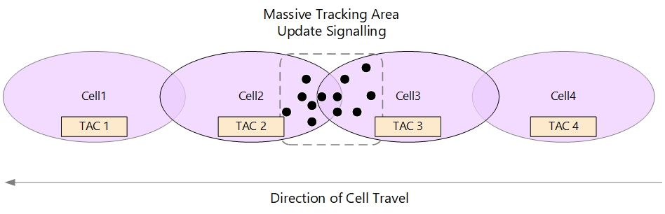
Figure 7.3.1.1-1: Moving Cells and Small tracking areas leading to massive TAU signalling

On the other hand, wide tracking areas would lead to high paging load in the satellite beams as illustrated in figure 7.3.1.1-2.
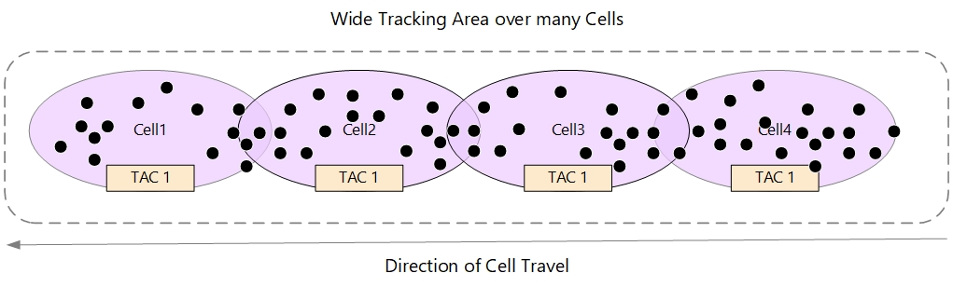
Figure 7.3.1.1-2: Moving Cells and wide tracking areas leading to higher Paging load
However, tracking areas must be dimensioned to minimise the TAUs as this is more signalling-intensive than paging on the network.
In practical tracking area design, one of the criteria affecting the performance and capacity is the limiting capabilities of MME/AMF platforms and the radio channel capacity.
Ping-pong effect generating excessive TAU, and it can be minimised by ensuring 10-20% overlaps between the adjacent cells and appropriate allocation of TAI List to UEs especially at the edge of cells/TAs.

Solution Overview
In order not to have TAU performed frequently by the UE triggered by the satellite motion, the tracking area should be designed to be fixed on ground (i.e. earth-fixes TA similar to NR-NTN). For NTN LEO, this implies that while the cells sweep on the ground, the tracking area code (i.e. TAC) broadcasted is changed, when the cell arrives to the area of next planned earth fixed tracking area location. The TAC broadcasted by the eNB needs to be updated as the eNB enters to the area of next planned tracking area. When the UE detects entering a tracking area that is not in the list of tracking areas that the UE previously registered in the network, a mobility registration update procedure will be triggered.

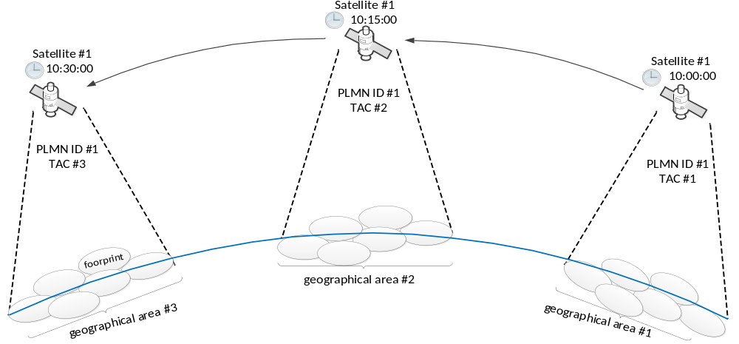
Figure 7.3.1.1-3: An example of updating TAC and PLMN ID in real-time for LEO with moving beams
As shown in Figure 7.3.1.1-3, network updates the broadcast TAC in real time according to the ephemeris and confirms that the broadcast TAC is associated with the geographical area covered by the satellite beam. UE listens to TAI = PLMN ID + TAC and determines to trigger registration area update procedure based on the broadcast TAC and PLMN ID when it moves out of the registration area.
Editor’s Note: Two possible options: (1) soft-switch broadcasting a list of TACs per cell and (2) hard-switch based on a single TAC per cell are currently considered in NR-NTN. The same solution as NR-NTN can be reused for IoT-NTN, if applicable.

7.3.1.2 Using ephemeris information and UE location information
Ephemeris information and UE location information can be used to help UEs perform measurement and cell selection/reselection, in addition to PCI and frequency information included in the broadcast system information [3] [10].
Editor’s Note: Provisioning of satellite ephemeris data and other information using System Information (SI) message for IoT-NTN is FFS.

7.3.1.3 Enhancements to UE mobility procedure
Cell selection/reselection for NR-NTN can be reused as a baseline [3] [10].
Editor’s Note: Detailed solutions of cell selection/reselection in eMTC/NB-IoT NTN need further discussion.

7.3.2 Connected mode mobility enhancements
Similar to NR-NTN [3], for LEO NTN, mobility management procedures should take satellite movement into account, while for GEO NTN, the large propagation delay needs to be accommodated.

7.3.2.1 Connected Mode Mobility for NB-IoT in NTN
There are no Connected Mode mobility procedures defined for NB-IoT. When an NB-IoT UE goes out of service coverage of the source cell, it experiences a Radio Link Failure (RLF). This triggers the UE to perform RRC connection re-establishment.

7.3.2.2 Connected Mode Mobility for eMTC in NTN
Challenges in connected mode mobility for eMTC based NTN are similar to the connected mode mobility issues in NR-NTN. These include (1) high latency associated with handover signalling, (2) measurement validity, (3) frequent handovers, (4) dynamic neighbour cell list, (4) handover of a large number of UEs and (5) impact of propagation delay difference in measurements [3] [10].
Editor’s Note: Agreements regarding handover (including Conditional Handover) for NR-NTN, will be discussed for possible adoption in eMTC based IoT-NTN, if beneficial.

8 Recommendations on the way forward

8.1 Recommendations from RAN1
TBA

8.2 Recommendations from RAN2
TBA

Annex A: Satellite ephemeris

Annex B: KPI and evaluation assumptions

B.1 Key Performance Indicators
KPIs defined in TR38.913 are considered.

B.2 Performance targets for evaluation purposes
Based on RAN2#105 conclusion on contribution R2-1901404 and SA1 specification requirements, the Non-Terrestrial network target performances per usage scenario for IoT connectivity (low power wide area service capability) was recommended in TR 38.821 as shown in Table B.2-1:
Table B.2-1: Non-Terrestrial network target performances per usage scenarios [source: TR 38.821]
Usage scenarios | Experience data rate (Note 1) |  | Overall UE density per km2  (Note 2) | Activity factor (Note 1) | Max UE speed | Environment | UE categories | Sources
Usage scenarios | DL | UL
IoT connectivity (low power wide area service capability) | 2 kbps | 10 kbps | 400 | 1,00% | 0 km/h | Extreme coverage | IoT | Device density: from R2-1901404 |6]  Data rate and activity factor: derived from Rel-13 TR 45.820 [4] Annex E.2 "Traffic models for Cellular IoT"
NOTE 1: As defined in TS 22.261 [5]
NOTE 2: The Overall UE density per km2 represents a peak value over a 40 km cell diameter. The actual value that can be achieved with a satellite will depend on the beam diameter.

Annex C (Informative):
Change history
Change history
Date | Meeting | TDoc | CR | Rev | Cat | Subject/Comment | New version
2021-01 | R2-113e | R2-2101455 |  |  |  | Skeleton TR | 0.0.1
2021-02 | R1#104e  R2#113e | R1-2101139  R2-2102492 |  |  |  | - Text proposal for TR 36.763 chapter related to RAN1  - Text proposal for TR 36.763 related to RAN2 | 0.0.2

